South African Soccer Dataset – SQL
1. View the first 100 rows of the dataset to understand its structure.
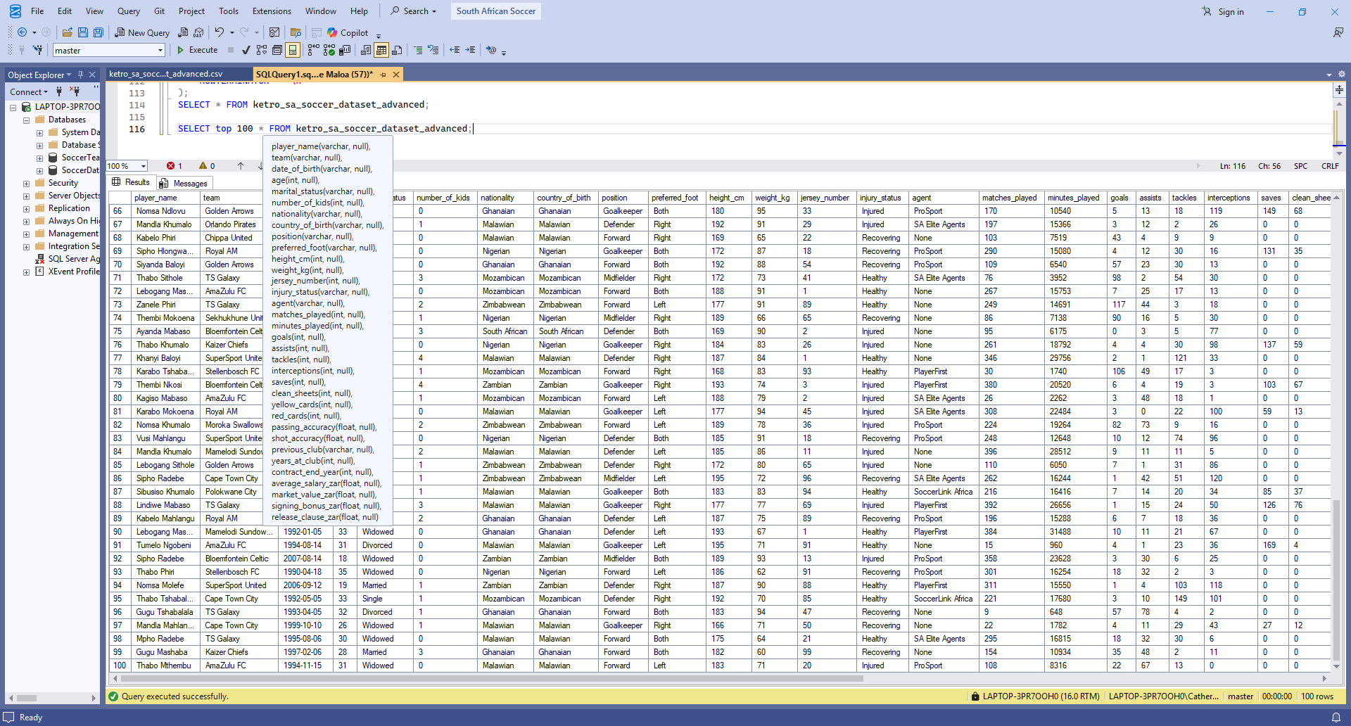
2. Count the total number of players in the dataset.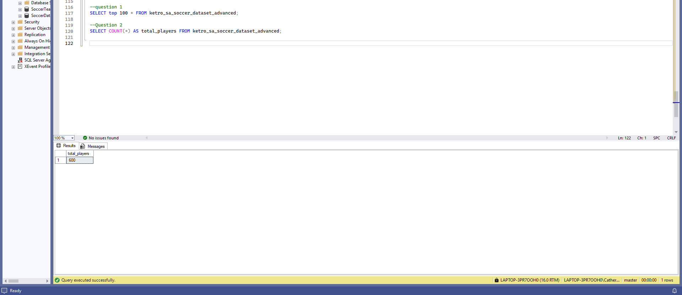

3. List all unique teams in the league. 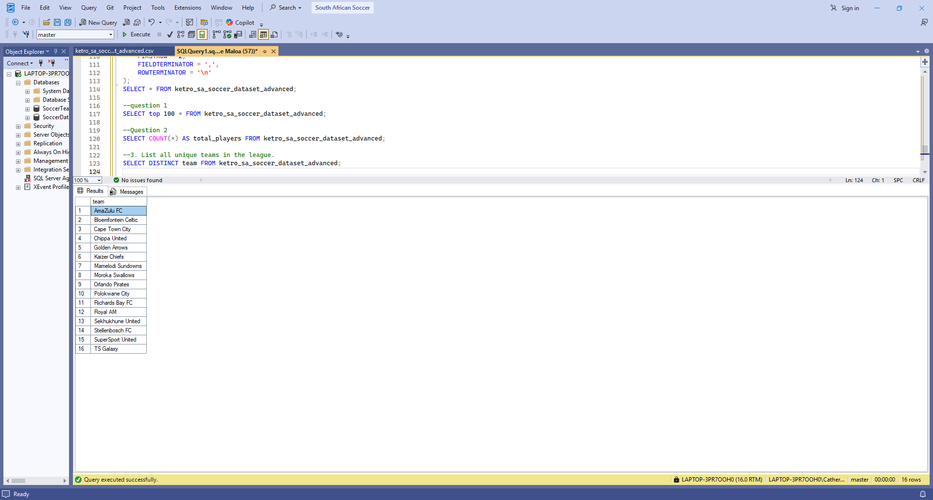

4. Count how many players are in each team. 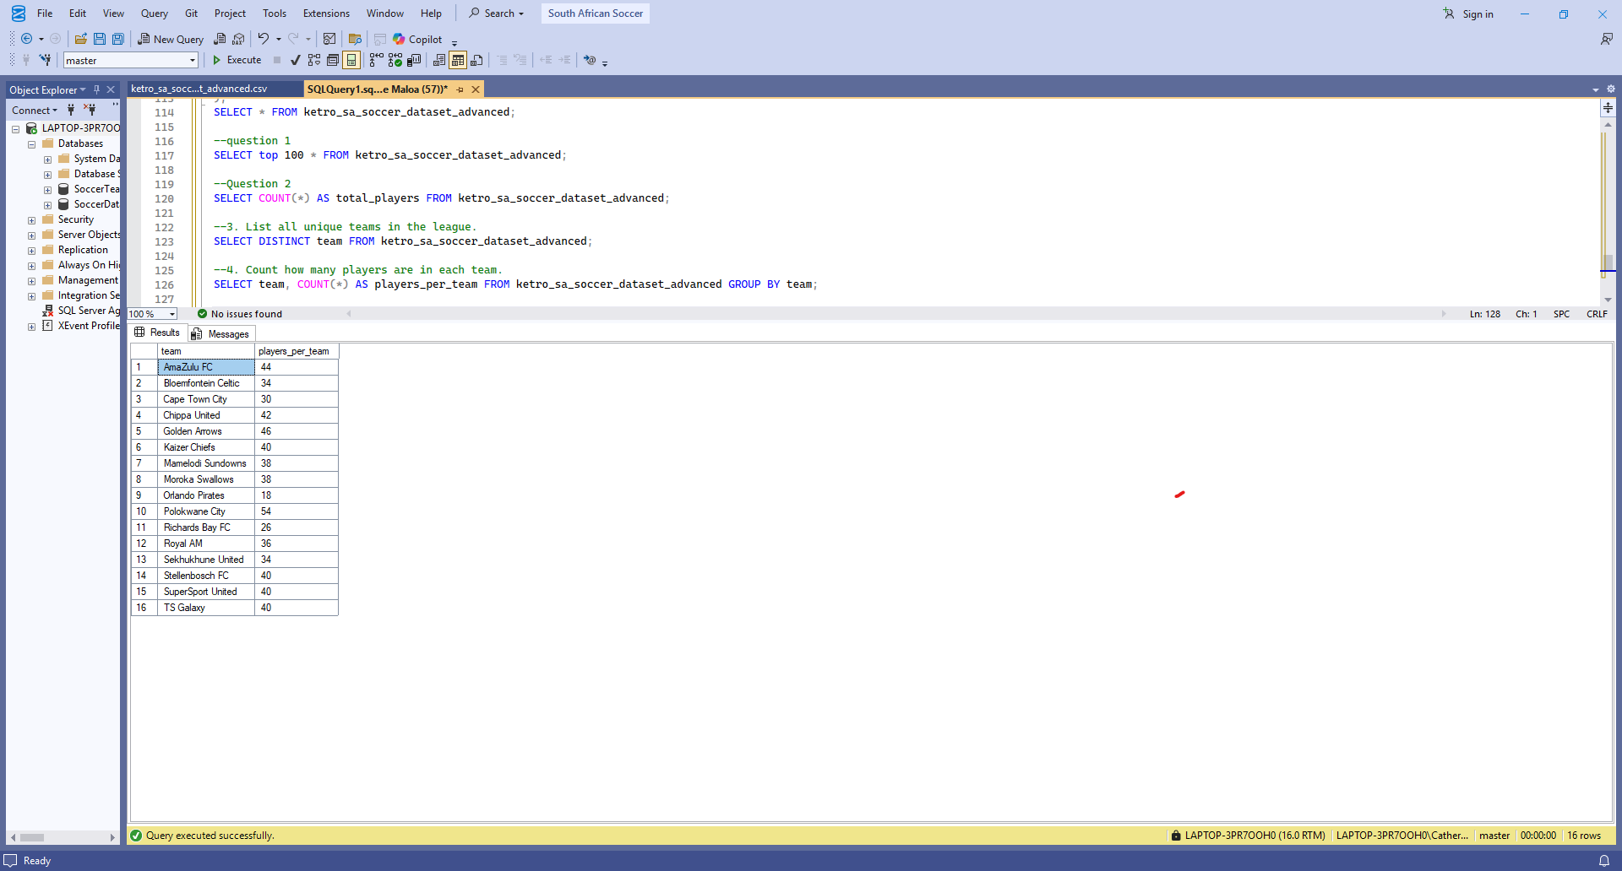

5. Identify the top 10 players with the most goals
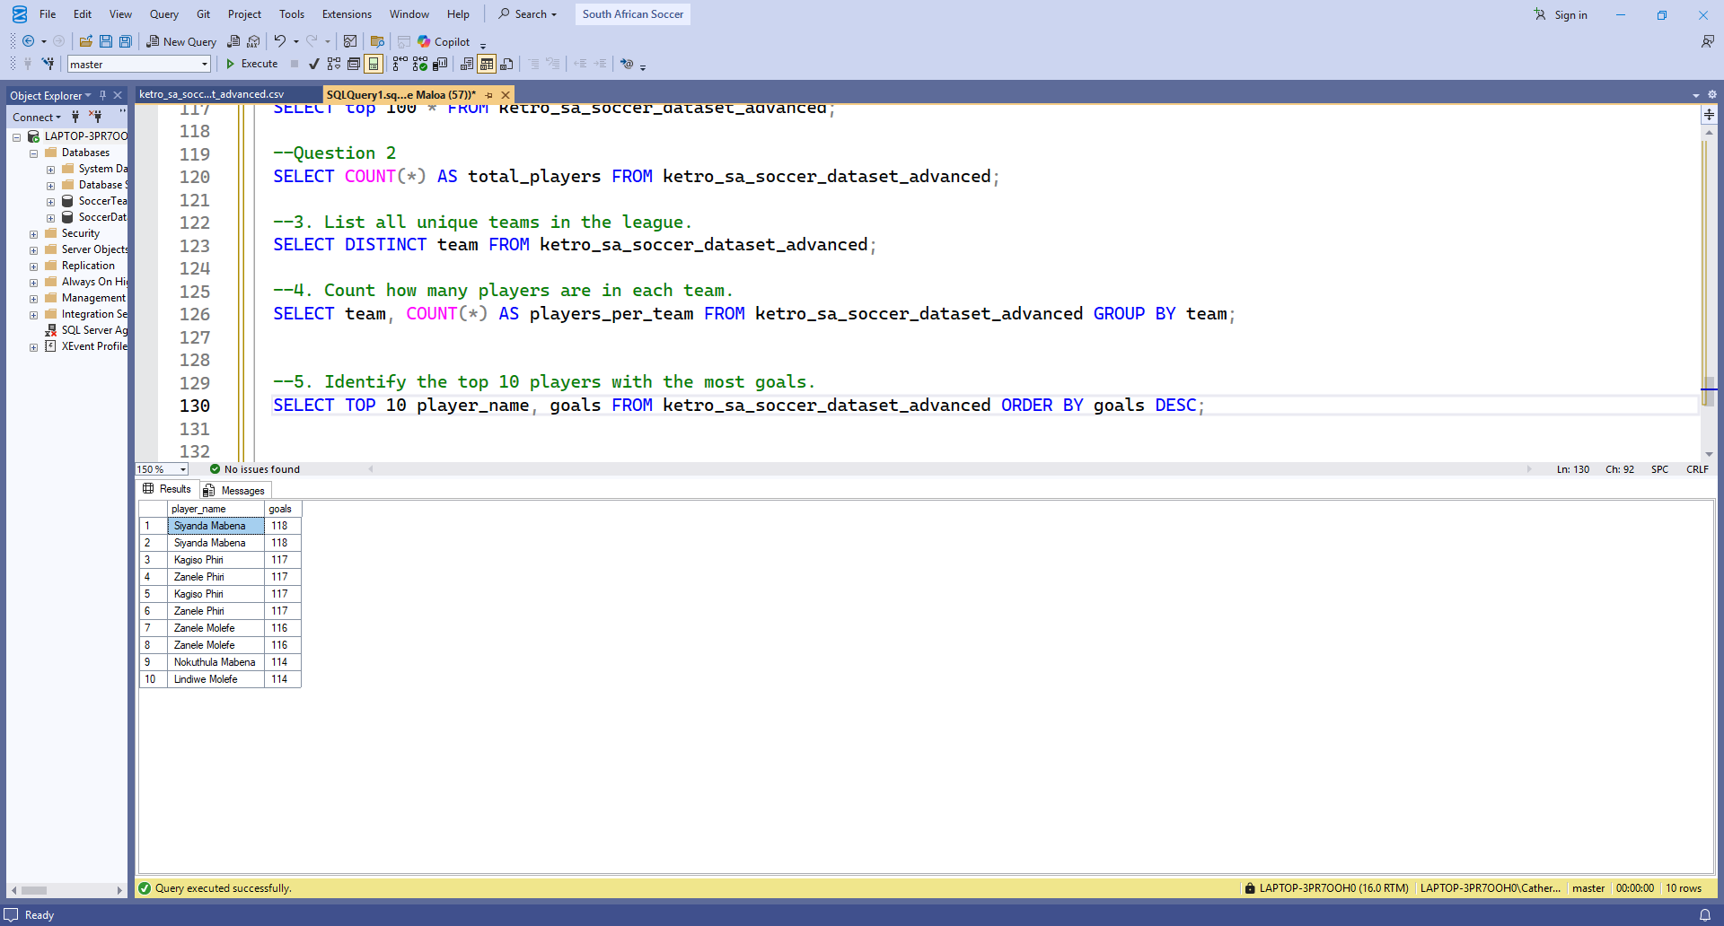

6. Find the average salary for players in each team
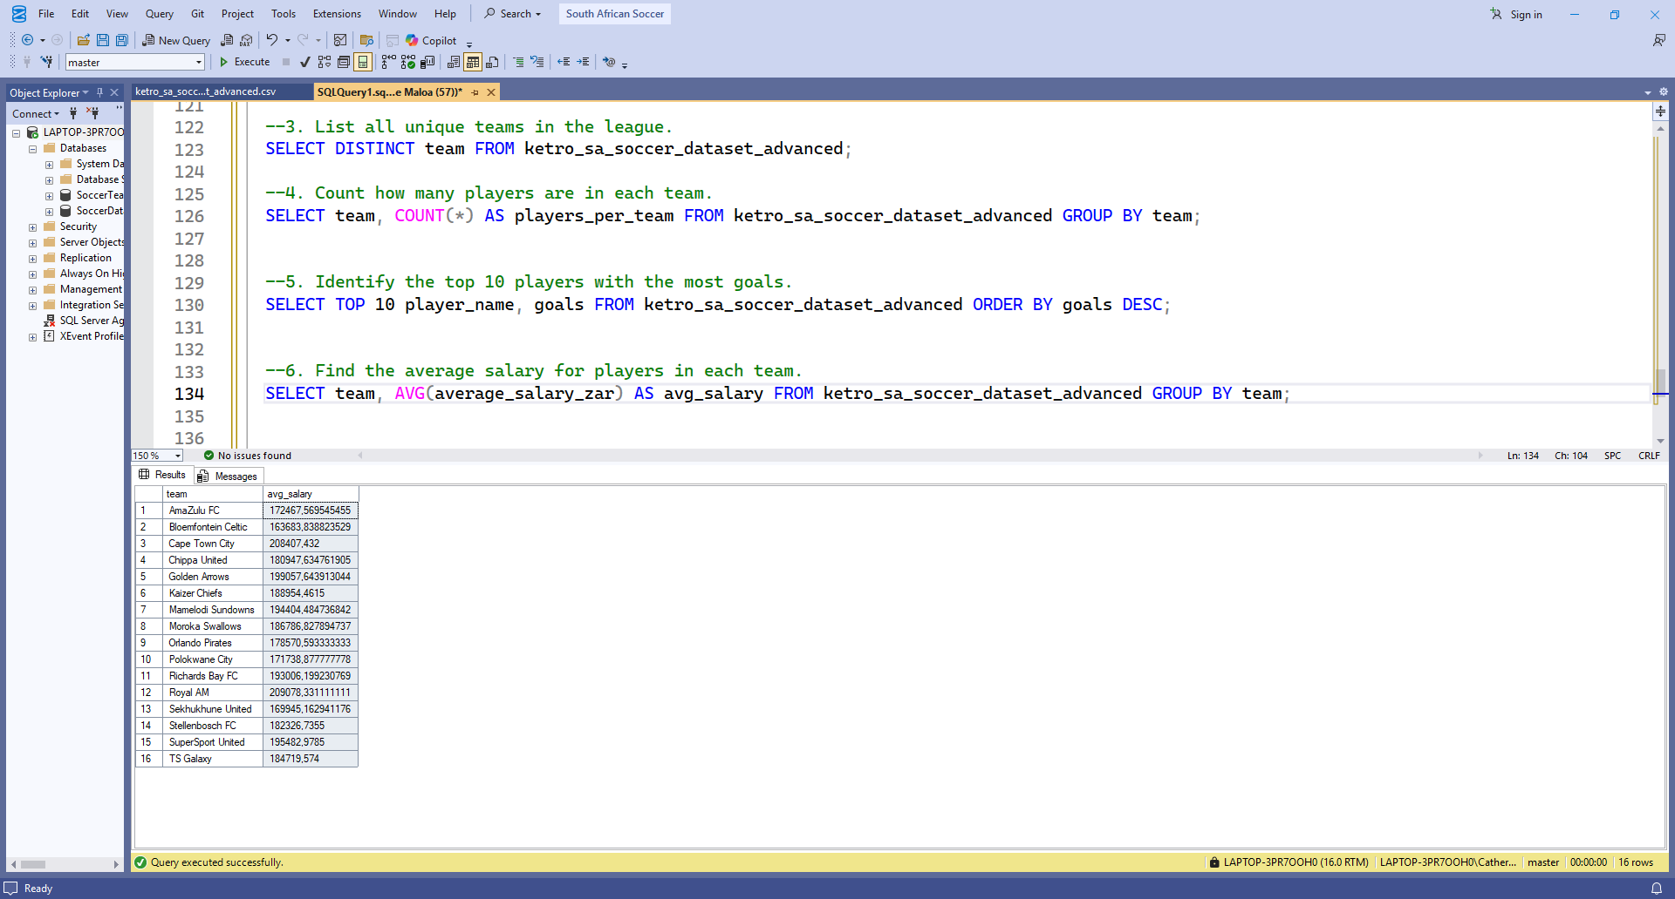

7. Retrieve the top 10 players with the highest market value.
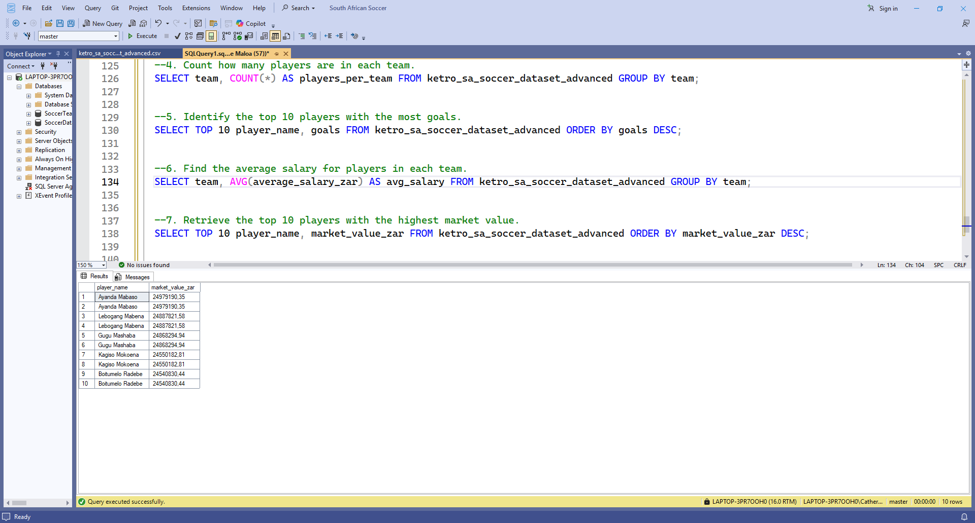

8. Calculate the average passing accuracy for each position.
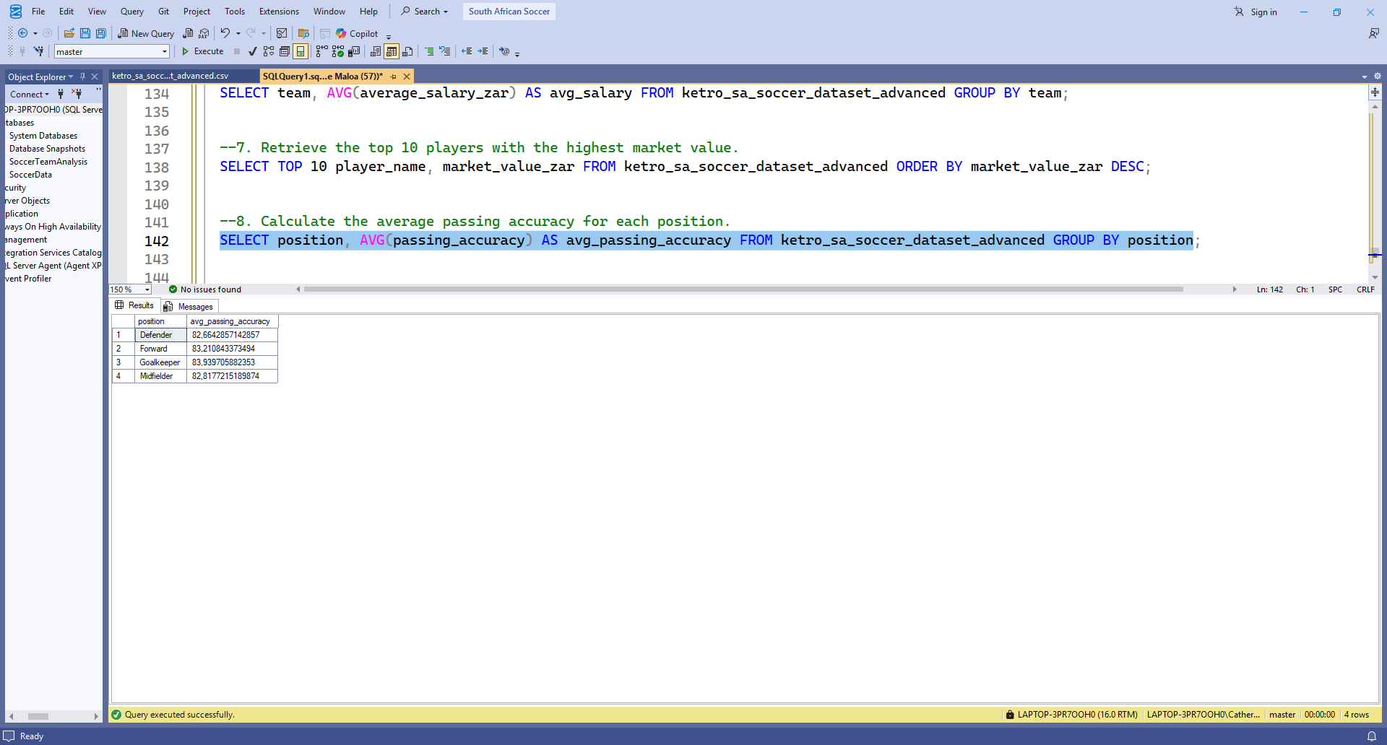

9. Compare shot accuracy with goals to find correlations.
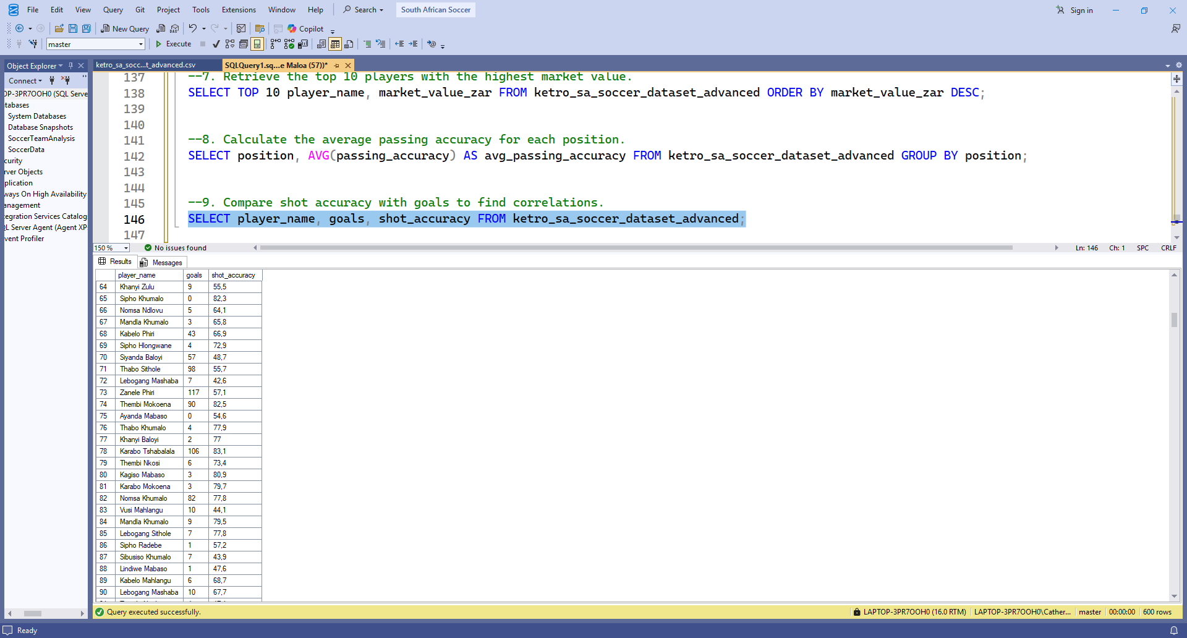

10. Compute total goals and assists for each team
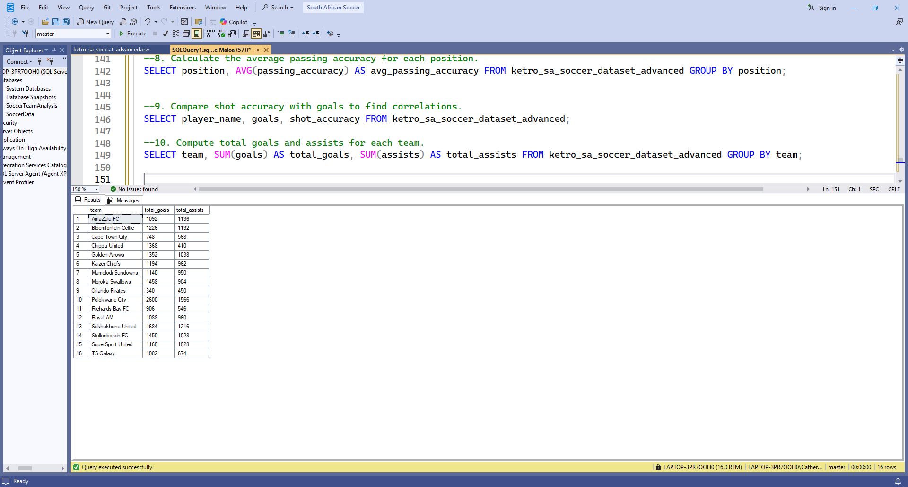

11. Count players by their marital status.
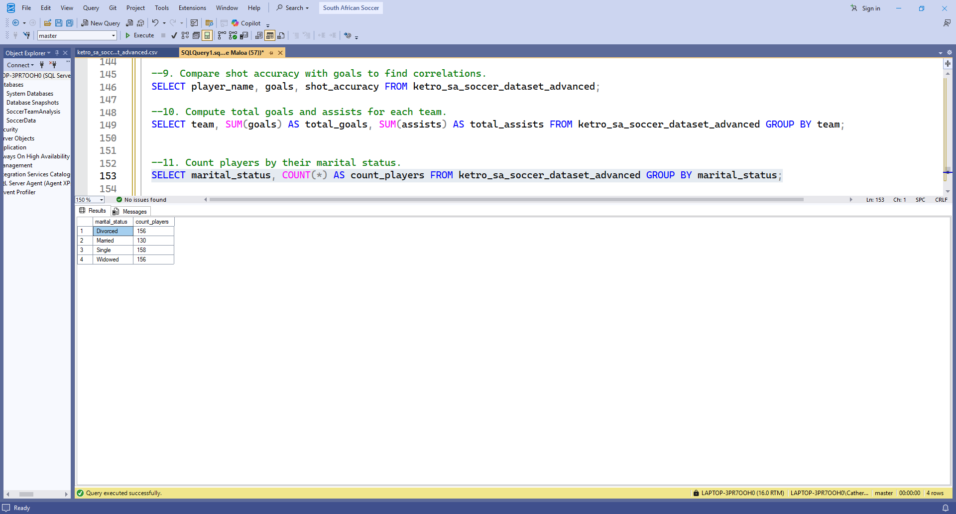

12. Count players by nationality.
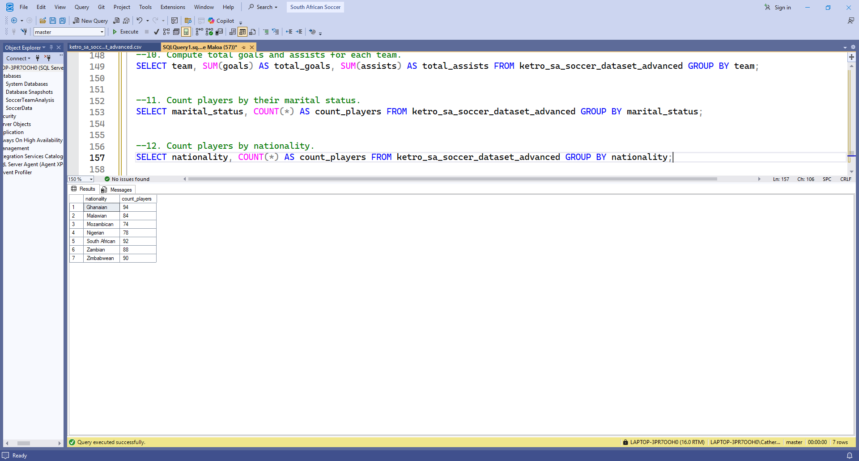
13. Find average market value grouped by nationality.
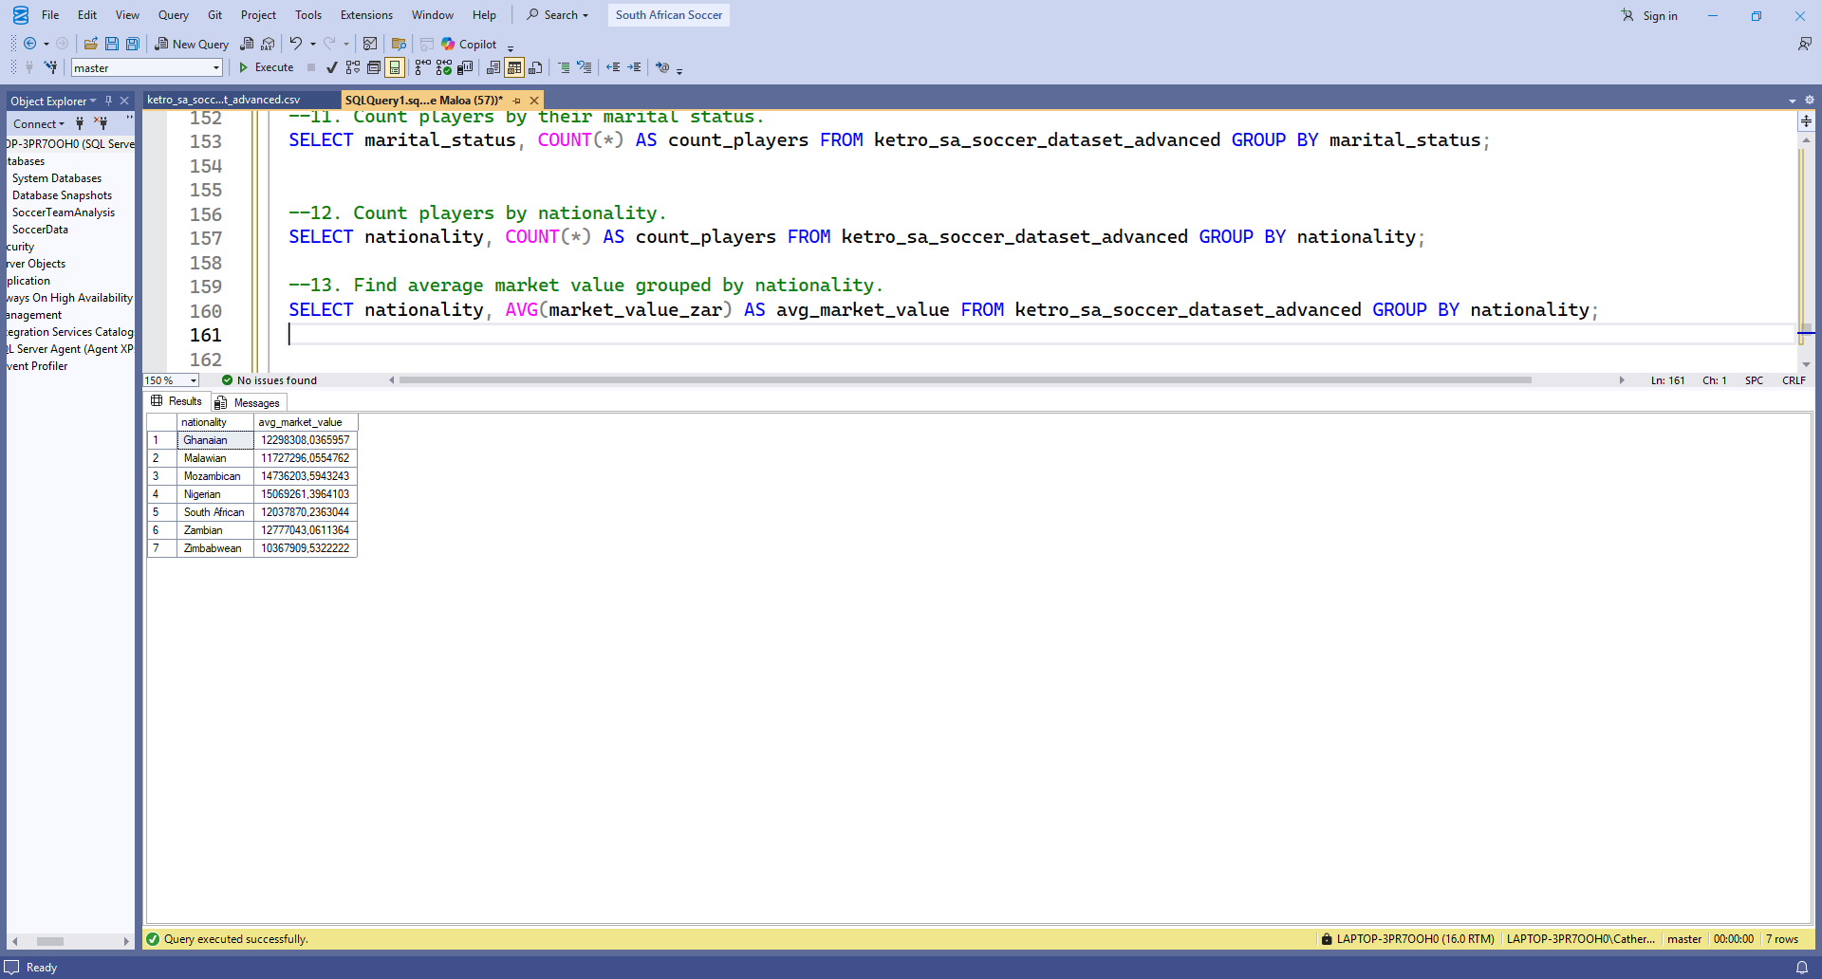
14. Determine how many player contracts end in each year.
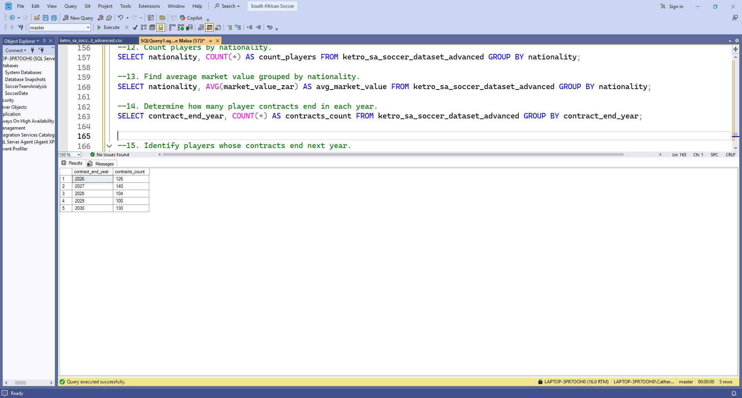

15. Identify players whose contracts end next year.
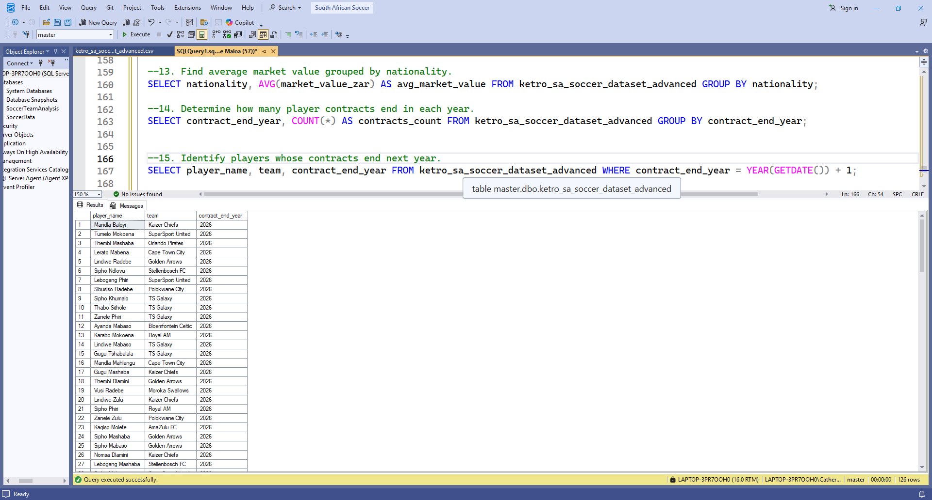

16. Summarize the number of players by injury status.
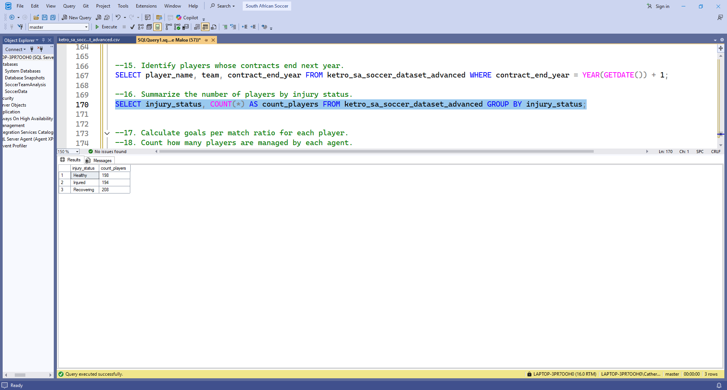
17. Calculate goals per match ratio for each player.
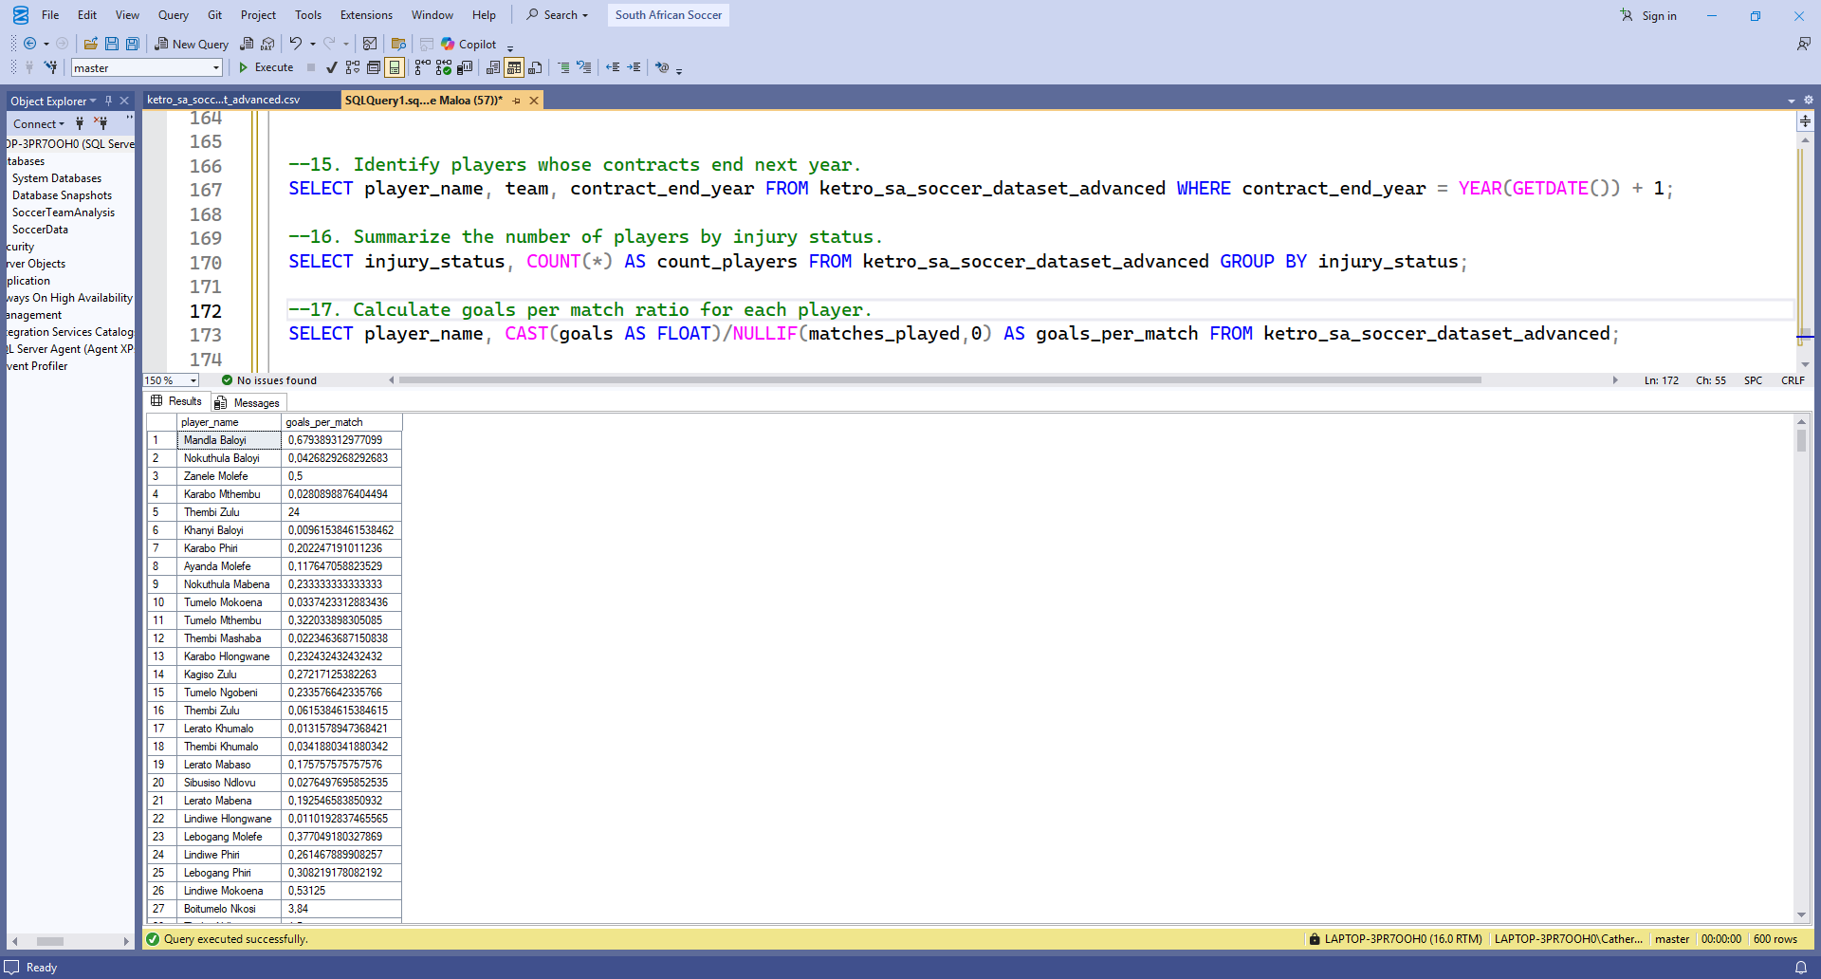
18. Count how many players are managed by each agent.
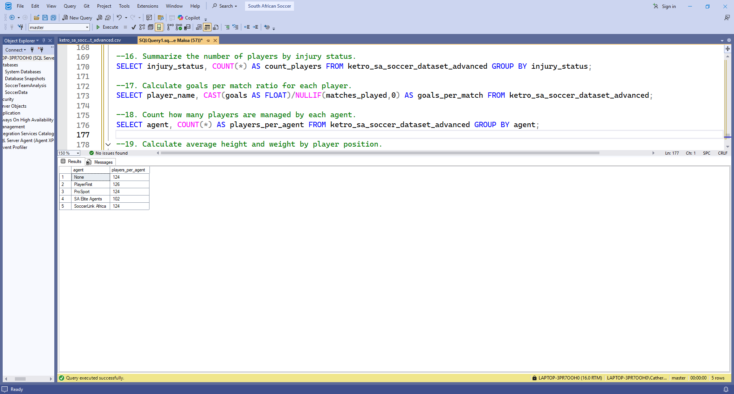

19. Calculate average height and weight by player position.
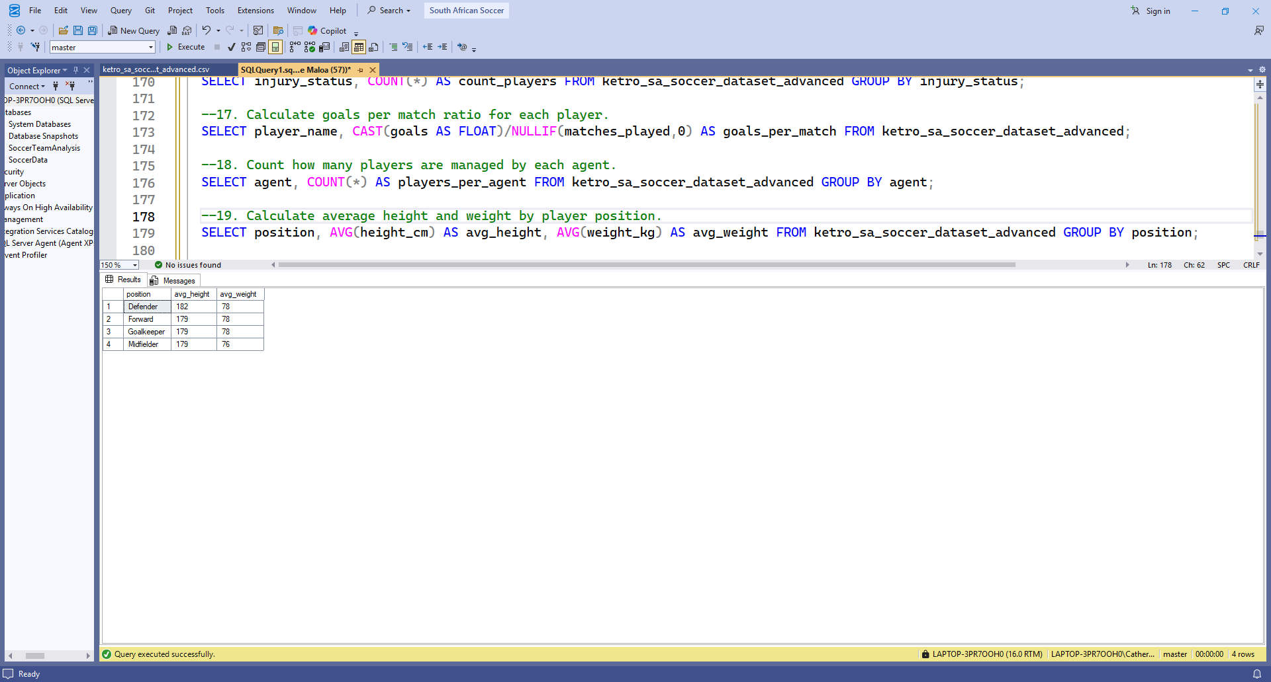

20. Identify players with the highest combined goals and assists.
